**DARJEELING CHILDREN’S TRUST**

The Old Paulites Association (Europe) was approached some time ago by Marilyn Adams, the Chairperson, of a small UK registered charity, Darjeeling Children’s Trust (DCT), about developing a closer association between the OPA(E) and DCT in order to provide support for the latter’s activities. In essence, the aim of DCT is to support underprivileged, disadvantaged and orphaned children and young people in Darjeeling into better education and to help improve their social and living conditions where this has an adverse impact on them achieving a better education.



DCT has 9 trustees (one of whom lives permanently in Darjeeling) and the Trustees are all volunteers, with none of them taking any personal expenses from monies raised so that all donations go directly to the children.

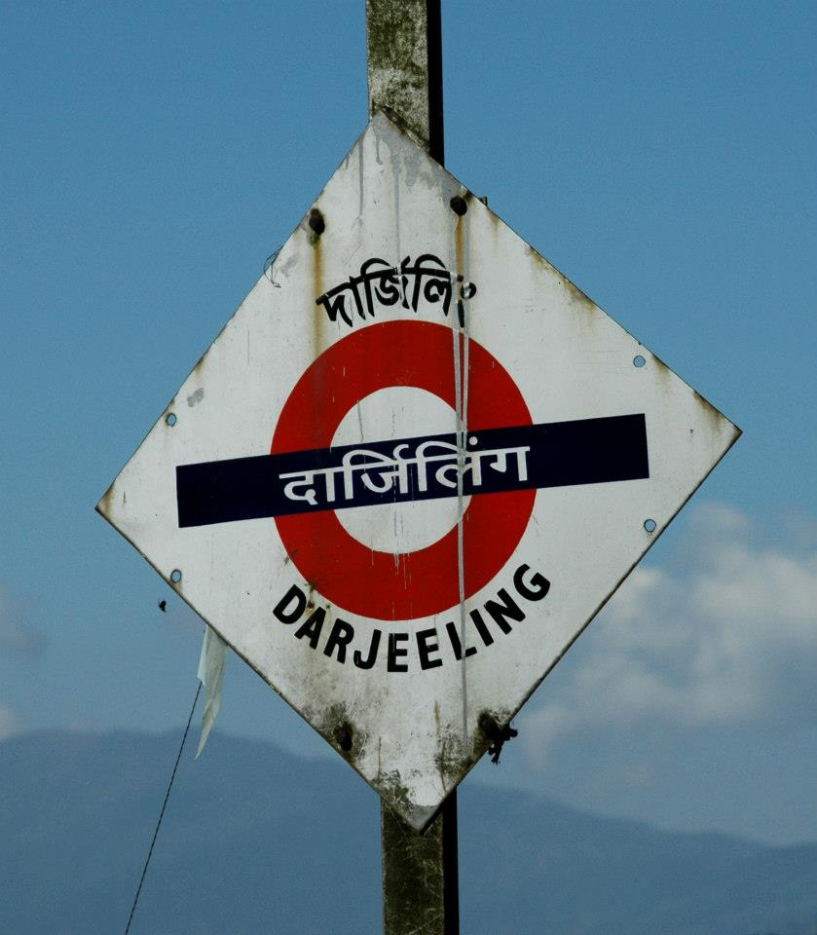

Further details about the DCT can be obtained from their website [www.darjeelingchildrenstrust.org.uk](http://www.darjeelingchildrenstrust.org.uk)

One of the projects the charity are helping with is the funding of a new, safe orphanage for 100 boys and girls in Darjeeling, as the then present buildings in which the boys were living were about 90 years old and had become unsafe, unusable and were starting to fall apart and slide downhill. Phase 1 of the project comprising a new dormitory housing some 60 boys was completed in late 2014 and the DCT are currently raising funds to allow Phase 2 to begin, to provide accommodation for some 40 girls together with the construction of offices, a dining room and a prayer room. The old boys home…

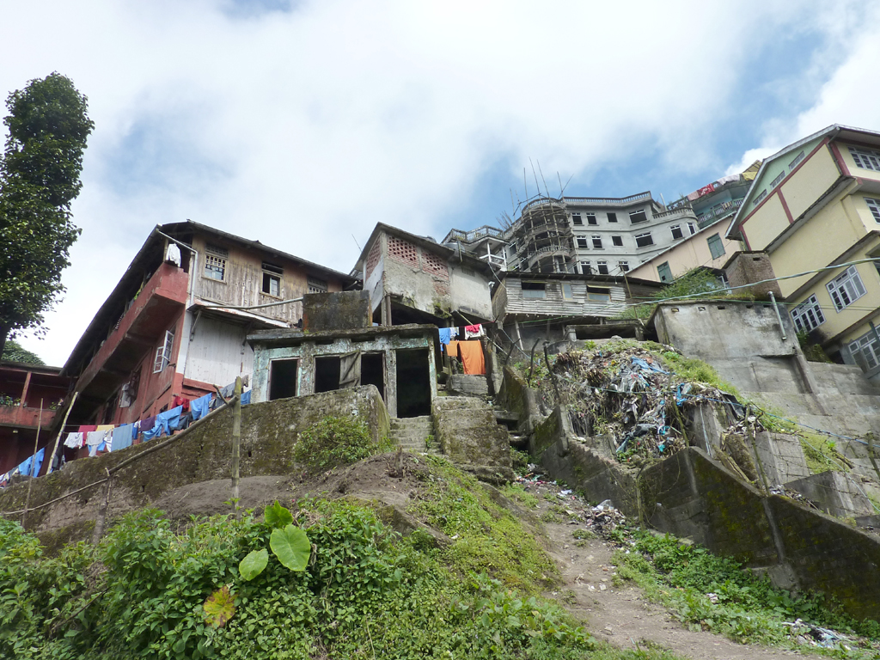

And the new…



In addition to the above, DCT currently facilitates the sponsorship of over 60 individual children to attend fee paying schools. These are children whose parents (who work, for instance, as porters and housemaids) often cannot afford to buy them pens and paper to support their education at school, the fees for which come from donations and also cover costs such shoes, a school bag, a plastic raincoat and wellingtons and school uniform.

DCT is helping a number of children acquire vocational skills and hospitality training. To further support the children’s education, DCT runs a travelling library and pays the salary of a part-time travelling librarian who visits some of the poorest primary schools every week with a stock of books, to tell stories with the children, teach them related songs and craft and help them explore literacy. DCT also launched the Darjeeling Music Festival in 2012 and repeated the success of this in 2014.

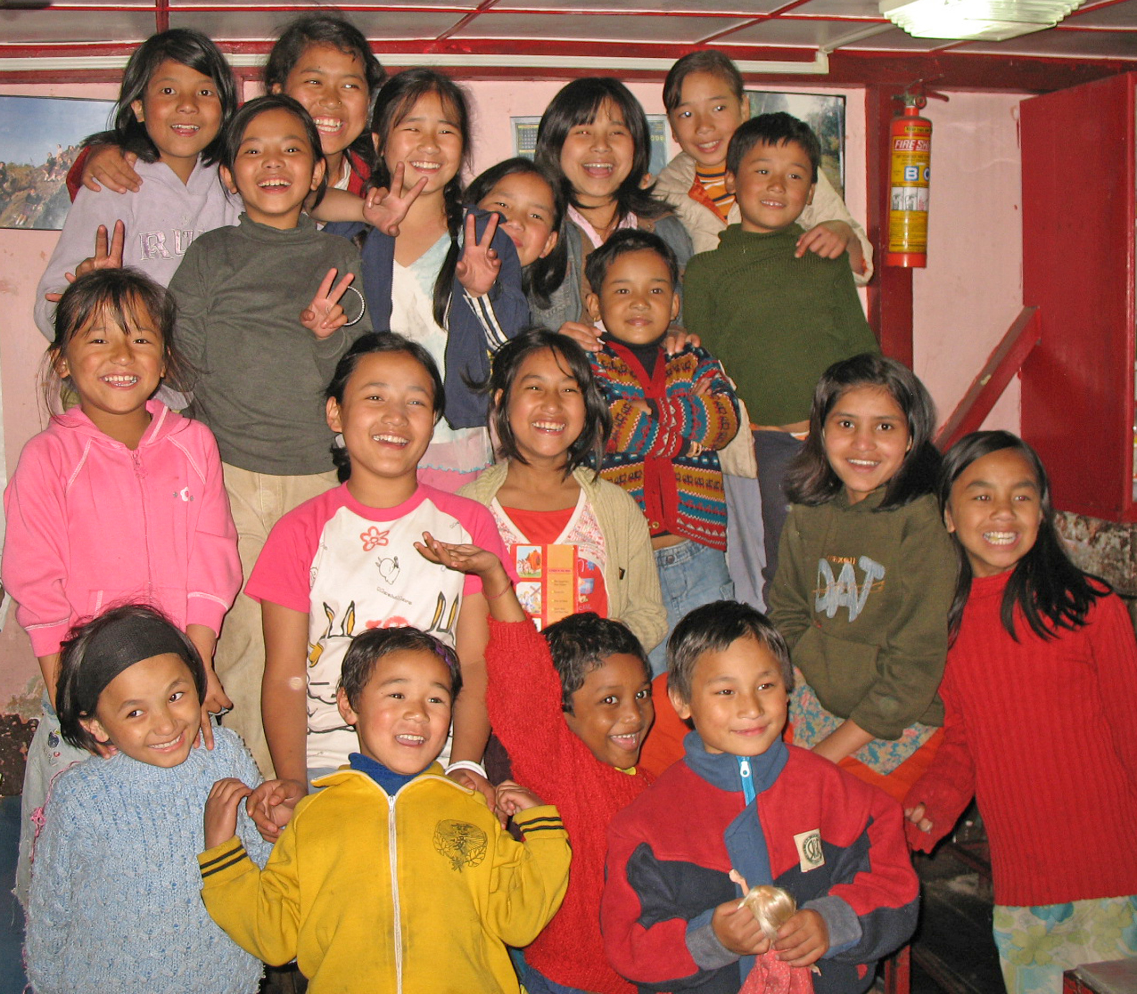

To further explain the work of DCT, one of the trustees, Hugh Heron, was invited to be a guest speaker at our 2015 Annual Reunion Dinner. Hugh gave a very interesting and informative presentation of the work of DCT with which those attending were impressed. Since then, the OPA(E) has been in discussion with DCT about how both the OPA(E) and the School could benefit from a closer association with each other by way of:

1. Promotion of DCT via Old Paulite connections UK and worldwide via web links and supporting the work of DCT, both operationally and financially, by the OPA(E) becoming a “DCT Partner”.
2. Encouraging direct cooperation between DCT schools and St Paul’s by way of the students at St Paul’s participating in certain ‘volunteering’ activities and, in particular, looking into improved career counselling for the older DCT sponsored children, subject to prior agreement with the Rector at St Paul’s.
3. The OPA(E) making a donation of £1,000 to the DCT to assist in funding their core projects, as referred to above and encouraging individual members to make any donations directly to DCT, should they wish to do so, to support the very worthwhile work of DCT.

In addition, a representative of DCT would attend for part of an OPA(E) committee meeting once per year to update the committee on their work. We look forward to a long and fruitful association with the Darjeeling Children’s Trust.

